

CS6P05 Project

Sports Facility Booking Application

Project Report
Final Submission

Name: Muhammod Belal Uddin
ID Number: 23032697
Date: Wednesday, 29 April 2026
First Supervisor: Dr Qicheng Yu
Second Supervisor: N/A

Declaration
Module: CS6P05 Deadline: 3pm Monday 5th May 2026
Module Leader: Dr. Elaheh Homayounvala Student ID: 23032697

PLAGIARISM
You are reminded that there exist regulations concerning plagiarism. Extracts from these regulations are printed below. Please sign below to say that you have read and understand these extracts:
Student signature: M B UDDIN Date: 29/04/26
This header sheet should be attached to the work you submit. No work will be accepted without it.
Extracts from University Regulations on Cheating, Plagiarism and Collusion
Section 2.3: "The following broad types of offence can be identified and are provided as indicative examples…
- Cheating: including taking unauthorised material into an examination; consulting unauthorised material outside the examination hall during the examination; obtaining an unseen examination paper in advance of the examination; copying from another examinee; using an unauthorised calculator during the examination or storing unauthorised material in the memory of a programmable calculator which is taken into the examination; copying coursework.
- Falsifying data in experimental results.
- Personation, where a substitute takes an examination or test on behalf of the candidate. Both candidate and substitute may be guilty of an offence under these Regulations.
- Bribery or attempted bribery of a person thought to have some influence on the candidate's assessment.
- Collusion to present joint work as the work solely of one individual.
- Plagiarism, where the work or ideas of another are presented as the candidate's own.
- Other conduct calculated to secure an advantage on assessment.
(viii) Assisting in any of the above.
Some notes on what this means for students:
1. Copying another student's work is an offence, whether from a copy on paper or from a computer file, and in whatever form the intellectual property being copied takes, including text, mathematical notation and computer programs.
2. Taking extracts from published sources without attribution is an offence. To quote ideas, sometimes using extracts, is generally to be encouraged. Quoting ideas is achieved by stating an author's argument and attributing it, perhaps by quoting, immediately in the text, his or her name and year of publication, e.g. "e = mc2 (Einstein 1905)". A references section at the end of your work should then list all such references in alphabetical order of authors' surnames. (There are variations on this referencing system which your tutors may prefer you to use.) If you wish to quote a paragraph or so from published work then indent the quotation on both left and right margins, using an italic font where practicable, and introduce the quotation with an attribution.

Abstract
The Sports Facility Booking Application is a web-based system developed to improve the process of booking sports facilities by replacing traditional manual booking methods with a modern digital solution. Many gyms, leisure centres, universities and sports organisations still rely on manual scheduling systems such as phone calls, paper records or face-to-face reservations, which can lead to booking conflicts, poor record management and inefficient communication between administrators and users. This project addresses these issues by developing an online platform that allows users to book sports facilities quickly and efficiently.
I developed it using Python Flask as the backend framework, SQLite as the database management system, and HTML/CSS for the frontend user interface. The application follows a role-based access system where users and administrators have different permissions. Members can register accounts, log in securely, search available facilities, view facility images, make bookings, cancel bookings, and manage their personal profiles. Administrators have enhanced privileges which include managing facilities, editing and deleting facilities, viewing all bookings, managing users, exporting booking reports in CSV format, and monitoring overall system statistics through an analytics dashboard.
Several validation and security mechanisms were implemented to improve system reliability. These include password hashing, prevention of duplicate bookings, session timeout management, booking date validation, and restricted booking time slots. The user interface was also improved to provide a professional and user-friendly experience.
The final product successfully meets the original project objectives while also introducing additional features beyond the initial proposal. The system demonstrates practical application of software engineering principles including database design, user authentication, CRUD functionality, testing, and interface design. Future improvements may include online payment integration, email notifications, mobile application support, and cloud deployment.

Table of Contents
Declaration 2
Abstract 3
Table of Contents 4
The report structure 6
Chapter 1:Introduction 7
Project topic and rationale 7
Project Aims and Objectives 7
Methodology 8
Chapter 2:Background Research 9
Literature review of related work 9
Impact of Digital Transformation on Booking Systems 10
Critical evaluation of related products/solutions 10
Current Trends in Online Booking Systems 10
Cybersecurity and Data Privacy in Booking Systems 11
The scope of the project 12
Review and justification of theories/models/development platforms/tools selected for use in the project 12
Chapter 3:Requirements Analysis and Specification or Problem Analysis and Specification 14
Functional Requirements: 14
Non-Functional Requirements: 15
Stakeholder Analysis: 15
Use Case Modelling 16
Chapter 4:Software Design or Research Methodology Design 17
User Interface Design 17
Database Tables Structure Design 18
Main Components of Software Architecture 19
Detailed Software Design Components 21
Chapter 5:Implementation and Testing or Research Results and Result Analysis 25
Software Implementation or Research Results 25
Software Testing or Analysis of the results 33
Additional Testing Approaches 35
Chapter 6:Evaluation of Results 35
System Performance and Scalability Evaluation 37
Commercial Viability and Real-World Application 38
Comparison Between Final System and Initial Proposal 38
Chapter 7:Conclusions 39
Appendices 42
Appendix A: Project Management 42
1.1 The original project plan from the Proposal 42
1.2 Review of your project process 43
1.3 Amendments to the original plan 43
1.4 Lessons learned in project management 43
References 44

The report structure
This report is organised into seven chapters, each focusing on different stages of the project development process.
Chapter 1: Introduction introduces the project topic, explains the rationale behind the project, outlines the aims and objectives, describes the development methodology used, and provides an overview of the report structure.
Chapter 2: Background Research explores existing booking systems, relevant technologies and research related to online booking platforms. It also evaluates similar systems and discusses how the project addresses existing limitations.
Chapter 3: Requirements Analysis identifies the functional and non-functional requirements of the system. It explains the needs of both users and administrators and defines the core system requirements.
Chapter 4: Software Design presents the design phase of the project including database design, system architecture, user interface design, and relevant diagrams such as use case diagrams, activity diagrams and entity relationship diagrams.
Chapter 5: Implementation and Testing explains how the application was developed using Flask, SQLite, HTML and CSS. It also demonstrates how the system was tested to ensure functionality, security and reliability.
Chapter 6: Evaluation critically evaluates the final system by analysing its strengths, weaknesses and overall performance against the original objectives.
Chapter 7: Conclusion and Future Work summarises the project outcomes, reflects on lessons learned during development, and suggests possible future improvements.

Chapter 1:Introduction

Project topic and rationale
My project focuses on the development of a Sports Facility Booking Application designed to simplify the process of reserving sports facilities through an online platform. Sports centres, gyms, universities, and leisure facilities often experience difficulties when managing bookings manually through paper records, phone calls, spreadsheets, or in-person reservations. These traditional methods can result in scheduling conflicts, double bookings, poor record management, and inconvenience for both customers and administrators.
The increasing reliance on digital systems has created a demand for more efficient online booking platforms that allow users to access services quickly and conveniently. A web-based booking system provides users with the ability to register accounts, view available facilities, book time slots, and manage their bookings without requiring physical interaction with staff members. At the same time, administrators require efficient tools to manage facilities, users, and booking records.
This project was chosen because it provides an opportunity to solve a real-world problem while applying software development skills gained throughout my undergraduate studies. The project combines database management, backend development, frontend design, authentication systems, and software testing into one complete application. It also reflects the growing demand for automation in service-based industries where customer convenience and operational efficiency are important.
The project is particularly relevant because many organisations continue to modernise their booking systems to improve user experience and reduce administrative workload. By developing this application, the project demonstrates how technology can improve operational efficiency while providing a practical and user-friendly solution for sports facility management.

Project Aims and Objectives
The main aim of this project is to design and develop a secure, efficient, and user-friendly web-based Sports Facility Booking Application that allows users to reserve sports facilities online while enabling administrators to manage bookings and facilities effectively.
To achieve this aim, the project set the following objectives:
- design and develop a web application using Python Flask, HTML, CSS, and SQLite.
- create a secure user registration and login system with password encryption.
- allow users to browse available sports facilities and search for specific facilities.
- enable users to book sports facilities by selecting available dates and time slots.
- prevent duplicate bookings for the same facility, date, and time slot.
- allow users to cancel existing bookings and manage their booking history.
- enable users to update their personal profile information.
- provide administrators with the ability to manage facilities through adding, editing, and deleting facilities.
- allow administrators to manage users and view all bookings made within the system.
- implement an export function that allows administrators to generate booking reports in CSV format.
- develop a professional and responsive user interface that improves usability.
- test the system thoroughly to ensure that all functional and non-functional requirements are met.
The successful completion of these objectives demonstrates the development of a complete booking management system that improves efficiency compared to traditional manual booking methods.

Methodology
The development of the Sports Facility Booking Application followed an iterative software development methodology. This approach was selected because it allowed the system to be developed in stages, tested regularly, and improved continuously based on issues identified during development.
The project began with requirements gathering and analysis to identify the key features required by both users and administrators. This included identifying the need for user authentication, facility booking functionality, booking management, administrative controls and validation features.
Following the requirements analysis stage, the system design phase was completed. This involved designing the database structure, user interfaces, system workflows and planning how different components of the application would interact. Diagrams such as entity relationship diagrams, use case diagrams and activity diagrams were used to support the design process.
The implementation stage involved developing the application using Python Flask as the backend framework due to its lightweight nature and simplicity for web application development. SQLite was selected as the database management system because it is easy to integrate and suitable for small to medium-sized applications. HTML and CSS were used to develop the user interface.
An iterative approach was particularly useful because multiple improvements were made throughout development. Initial versions of the application included basic registration, login and booking functionality. Additional features such as facility search, booking cancellation, profile management, booking analytics, CSV export functionality and improved user interface design were introduced later as the project evolved.
Testing was conducted continuously throughout development to identify bugs, improve usability and ensure that all requirements were successfully implemented. This included testing authentication features, booking validation, administrative functionality and database operations.
Overall, the iterative methodology allowed flexibility throughout the development process and ensured that the final system was both functional and user-friendly.

Chapter 2:Background Research
This chapter provides a critical review of related work, and products with an aim to demonstrate a specialist understanding of the project topic, including its fundamentals and the state-of-the-art, i.e. the current developments and potential areas (i.e. “gaps”) for future development.
The review of the related work provides the context for the project work within the chosen topical area and relate the project to what is already known and available. As a result, the scope of the project can be determined.
Further, the chapter also reviews and describes relevant theories, methods and software/tools, which will be used in the project. Alternative options are discussed, and choices are justified.
It is very important to note that your review should not be simply a description of what others have published in the form of a set of summaries, but should take the form of a critical discussion, showing insight and an awareness of differing arguments, theories and approaches. It should be a synthesis and analysis of the relevant and up to date published work, relating at all times to your own purpose and rationale.
This chapter includes the following main contents.

Literature review of related work
Online booking systems have become increasingly important across multiple industries including healthcare, hospitality, education and sports management. These systems aim to improve efficiency by automating reservation processes and reducing reliance on manual scheduling methods. According to Laudon and Laudon (2020), information systems improve operational performance by enabling organisations to manage resources more efficiently through digital platforms.
Within sports management environments, booking systems are commonly used to manage access to facilities such as gyms, football pitches, tennis courts and swimming pools. Research shows that manual booking systems often create operational inefficiencies including scheduling conflicts, double bookings and poor record management (Sommerville, 2016). These problems are particularly common in smaller organisations that still rely on spreadsheets, telephone calls or face-to-face bookings.
Studies on online reservation systems highlight several important requirements including usability, reliability and security. Pressman and Maxim (2020) emphasise that modern software systems must provide intuitive interfaces while maintaining strong validation mechanisms to protect system data and users.
Cloud-based booking platforms have also become increasingly popular because they provide scalability and accessibility. However, research suggests that smaller organisations may not require complex enterprise-level systems and may benefit from simpler and lower-cost solutions.
This project addresses these gaps by developing a lightweight sports facility booking platform that combines usability, security and administrative functionality within a simplified system.

Impact of Digital Transformation on Booking Systems
Digital transformation has significantly changed how organisations manage customer interactions and operational processes. Booking systems are one example of how traditional manual operations have been replaced by automated digital platforms.
In the past, sports centres relied heavily on paper schedules, telephone calls and in-person reservations. These methods often created inefficiencies and increased the likelihood of booking conflicts.
Modern digital systems provide users with 24-hour access to services through web applications and mobile devices. This improves customer convenience and reduces administrative workload.
Digital transformation also enables organisations to collect data that can improve decision making. Booking analytics allow organisations to understand peak demand periods and improve resource allocation.
The increasing use of artificial intelligence, automation and cloud technologies continues to transform booking systems globally. And this project reflects these wider technological trends by replacing manual processes with an efficient digital solution.

Critical evaluation of related products/solutions
Several existing booking systems were reviewed during this project.
Commercial booking platforms such as Mindbody (2026) and TeamUp (2026) provide advanced scheduling tools for gyms and fitness centres. These systems include payment processing, membership subscriptions and mobile applications. While these platforms offer strong functionality, they can be expensive for smaller organisations and may contain unnecessary features for basic facility management.
University sports booking systems often allow students to reserve sports halls, gyms and courts through institutional portals. These systems are generally effective but are usually restricted to specific organisations and lack flexibility for custom development.
Manual booking systems remain common in smaller leisure centres. These systems typically involve telephone reservations, spreadsheets or in-person bookings. Although these methods have low implementation costs, they often lead to errors, inefficient scheduling and poor user experience.
The proposed Sports Facility Booking Application provides a balance between simplicity and functionality. Unlike manual systems, it automates booking management. Unlike large commercial platforms, it remains lightweight, affordable and easier to customise.

Current Trends in Online Booking Systems
The rapid growth of digital transformation has significantly influenced how organisations manage customer services and internal operations. Online booking systems have become increasingly common in industries such as transportation, healthcare, hospitality, education and sports management. These systems provide organisations with opportunities to improve efficiency while reducing operational costs.
One major trend within modern booking systems is the integration of cloud computing technologies. Cloud-based booking platforms allow organisations to store data remotely while providing users with access from multiple devices and locations. According to Sommerville (2016), cloud systems improve scalability and allow organisations to expand services without major infrastructure investments. However, cloud-based solutions may introduce higher operational costs for smaller organisations.
Mobile accessibility has also become a major expectation among modern users. Many customers now prefer booking services through smartphones and tablets rather than traditional desktop systems. Commercial platforms increasingly offer dedicated mobile applications to improve convenience.
Artificial intelligence is also beginning to influence booking systems. AI-powered recommendation systems can suggest booking times based on user behaviour and previous booking history. Chatbots are also used to automate customer service interactions.
Despite these advancements, smaller organisations often require simpler solutions that focus on affordability and usability rather than enterprise-level complexity. This project intentionally focuses on developing a lightweight web-based platform that delivers core booking functionality without introducing unnecessary complexity.
The research conducted demonstrated that there is still strong demand for simplified booking systems that can be customised for smaller organisations such as sports centres, educational institutions and leisure facilities.

Cybersecurity and Data Privacy in Booking Systems
As online booking systems continue to expand across multiple industries, cybersecurity and data privacy have become increasingly important considerations. Booking platforms often store sensitive personal information including names, email addresses, passwords and transaction records. If security measures are weak, organisations may become vulnerable to cyber threats such as data breaches, account hijacking and unauthorised system access.
According to Pressman and Maxim (2020), secure authentication mechanisms should be integrated into modern software systems to reduce the risk of security vulnerabilities. Many older booking systems continue to store passwords in plain text format, which creates serious security risks if databases are compromised. This project addressed this issue by implementing password hashing using Werkzeug security functions to ensure that user passwords are encrypted before being stored in the SQLite database.
Data privacy regulations such as the General Data Protection Regulation (GDPR) have also influenced how organisations manage user data. Organisations operating within the United Kingdom must ensure that personal information is collected, stored and processed responsibly. Although this project was developed as a local academic prototype, future deployment would require stronger compliance measures including privacy policies, encrypted database storage and secure hosting infrastructure.
Another cybersecurity concern involves session security. Users who remain logged into public devices may expose their accounts to unauthorised access. To reduce this risk, session timeout functionality was implemented within the system to automatically log users out after periods of inactivity.
These security considerations demonstrate that modern booking systems must prioritise both convenience and protection of user information.

The scope of the project
The scope of this project focuses on developing a web-based application that allows users to book sports facilities online while enabling administrators to manage the system.
The project includes:
- user registration and login
- role-based access control
- facility searching
- facility booking
- booking cancellation
- profile management
- facility management
- booking management
- user management
- booking analytics
- CSV export functionality
The project does not include:
- online payment systems
- email notification systems
- mobile application development
- cloud deployment
- third-party integrations
These exclusions were necessary due to time constraints and project scope limitations.

Review and justification of theories/models/development platforms/tools selected for use in the project
Several technologies were evaluated before development began.
Python was selected because of its readability and efficiency in rapid development environments.
Flask was chosen over larger frameworks such as Django because it is lightweight and provides greater flexibility for smaller projects. Flask allowed the application to be built quickly without unnecessary complexity.
SQLite was selected instead of MySQL or PostgreSQL because it requires minimal configuration and is suitable for standalone applications.
HTML and CSS were used for frontend development due to their simplicity and compatibility with Flask templates.
Werkzeug security functions were used for password hashing to improve authentication security.
Visual Studio Code was selected as the development environment because it provides flexibility, debugging support and integration with Python development tools.
These technologies were selected because they aligned well with project requirements and supported efficient development.

Chapter 3:Requirements Analysis and Specification or
Problem Analysis and Specification
This chapter identifies and analyses the requirements of the Sports Facility Booking Application. Requirements analysis is a critical stage of software development because it helps define what the system must achieve and ensures that the final product meets user needs.
The chapter identifies both functional and non-functional requirements of the system. It also considers the needs of different stakeholders, including general users and system administrators.
The analysis carried out in this chapter helped define the system boundaries and ensured that all key features were considered before development began.

Functional Requirements:
The Sports Facility Booking Application must allow users to:
- Register for an account
- Log into the system
- Log out securely
- View available sports facilities
- Search for facilities
- View facility details
- Book facilities
- Cancel bookings
- View booking history
- Update personal profile information
The system must allow administrators to:
- Log into the system
- Manage facilities
- Add new facilities
- Edit facility details
- Delete facilities
- View all bookings
- Delete bookings
- Manage users
- Delete users
- Export booking reports in CSV format
- View booking analytics dashboard
The system must also:
- Prevent double bookings
- Validate booking dates
- Restrict invalid booking times
- Store booking data securely

Non-Functional Requirements:
Usability:
The system should be simple and user-friendly for both members and administrators.
Security:
Passwords must be encrypted using hashing techniques. Role-based access control should restrict admin features.
Performance:
The system should process bookings quickly without long delays.
Reliability:
The system should prevent booking conflicts and maintain accurate records.
Maintainability:
The code should be structured in a way that allows future updates and modifications.
Scalability:
The system should allow future expansion such as payment integration or mobile support.

Stakeholder Analysis:
The main stakeholders involved in this project include:
Members/Users:
Users require a simple system that allows them to register, book facilities and manage bookings.
Administrators:
Administrators require tools to manage facilities, bookings and users.
Sports Facility Organisations:
Organisations benefit from improved efficiency and reduced administrative workload.
Developer:
The developer is responsible for ensuring the system meets technical and functional requirements.

Use Case Modelling
The major system use cases include:
- UC1 – Register Account
- UC2 – Login
- UC3 – Search Facilities
- UC4 – Book Facility
- UC5 – Cancel Booking
- UC6 – Update Profile
- UC7 – Manage Facilities (Admin)
- UC8 – Manage Bookings (Admin)
- UC9 – Manage Users (Admin)
- UC10 – Export Booking Reports (Admin)

Up until now, we have identified the major system requirements of the Sports Facility Booking Application. These requirements formed the foundation for the system design and implementation stages discussed in later chapters.

Chapter 4:Software Design or
Research Methodology Design
This chapter explains how the Sports Facility Booking Application was designed before implementation. It focuses on interface design, database structure, system architecture, logical design components and use case realisation. The purpose of this chapter is to demonstrate how software engineering design principles were applied to create a structured and maintainable solution.

User Interface Design
The user interface was designed with usability, accessibility and consistency in mind. Since the system supports both regular users and administrators, the interface needed to provide clear navigation while ensuring that both user types could easily access relevant functionality.

The frontend was developed using HTML templates integrated with Flask’s Jinja templating engine, while CSS was used to create a modern and visually consistent interface. A dark blue gradient colour scheme was selected to give the application a professional appearance while maintaining readability. White content cards were implemented to improve content organisation and visual separation.
The interface follows a consistent navigation structure across all pages through a reusable navigation bar. This allows users to easily move between different sections of the system.
User Interfaces Designed
For regular members:
- Homepage
- Registration page
- Login page
- User dashboard
- Facility search page
- Facility booking page
- Booking confirmation page
- My bookings page
- Profile management page
For administrators:
- Admin dashboard
- Facility management page
- Booking management page
- User management page
- Booking export functionality page
Additional user experience improvements include:
- search functionality for facilities
- facility image cards
- booking status labels
- confirmation messages
- responsive layout design
- clear button styling

Database Tables Structure Design
The system uses SQLite as its database management system due to its lightweight nature and ease of integration with Flask applications.
The database was designed using a relational model and consists of three primary tables:
Field Name | Data Type | Description
Id | Integer (PK) | Unique user identifier
Name | Text | User full name
Email | Text | Unique email address
password | Text | Hashed password
Role | Text | Defines admin or member role

Field Name | Data Type | Description
Id | Integer (PK) | Unique facility identifier
Name | Text | Facility name
description | Text | Facility description

- Bookings Table
This table stores all booking records.
Field Name | Data Type | Description
Id | Integer (PK) | Unique booking identifier
user_id | Integer (FK) | References users table
facility_id | Integer (FK) | References facilities table
Date | Text | Booking date
time_slot | Text | Booking time

- Database Relationships
The database relationships are as follows:
- One user can make multiple bookings
- One facility can receive multiple bookings
- Each booking belongs to one user
- Each booking belongs to one facility
A unique constraint was also implemented to prevent duplicate bookings for the same facility at the same date and time slot.
Entity Relationship Diagram of Sports Facility Booking System:
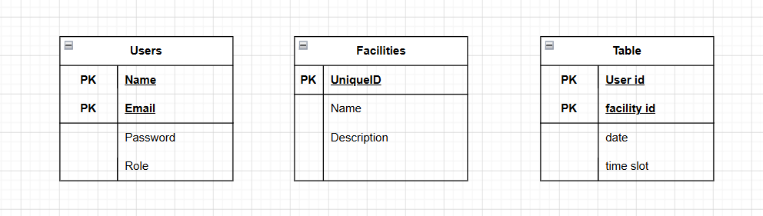

Main Components of Software Architecture
The application follows a layered architecture model which separates responsibilities between frontend presentation, backend logic and database storage.
Presentation Layer
This layer handles user interaction and includes:
- HTML templates
- CSS styling
- navigation interfaces
- forms
- dashboards

Application Layer
This layer contains Flask backend logic and handles:
- routing
- authentication
- booking validation
- session management
- facility search
- profile updates
- administrative operations

Data Layer
This layer consists of the SQLite database which stores:
- user records
- facility records
- booking records

Security Layer
Security mechanisms implemented include:
- password hashing
- session timeout controls
- role-based access restrictions
- booking validation controls
This layered design improves maintainability and ensures that each part of the system has clearly defined responsibilities.
System Architecture Diagram:
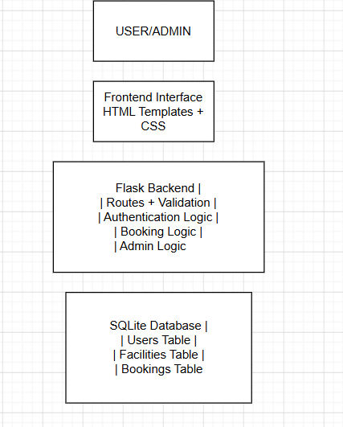

Detailed Software Design Components
Although the application does not heavily rely on object-oriented class structures, it contains several major functional modules that operate as logical software components.
Security Design Considerations
Security was an important consideration during the design stage of the Sports Facility Booking Application. Since the system stores personal user information and booking records, several security measures were incorporated into the design.
Password security was prioritised through the implementation of password hashing using Werkzeug security functions. This ensures that passwords are not stored in plain text format within the database. Even if database records were compromised, user passwords would remain protected.
Role-based access control was also implemented to ensure that administrators and regular users have different levels of access. Regular users are restricted to booking-related activities, while administrators are granted access to system management features.
Session management was designed to improve account security. Sessions automatically expire after a period of inactivity, reducing the risk of unauthorised account access.
Input validation was another important security consideration. Booking dates and times are validated to prevent invalid submissions. Duplicate booking prevention also protects system integrity.
Future versions of the system could further improve security by implementing multi-factor authentication, stronger password policies and cloud-based encrypted databases.
These design decisions helped improve the overall reliability and trustworthiness of the application.

Authentication Module
Responsible for:
- user registration
- login
- logout
- password encryption
- session management

Facility Management Module
Responsible for:
- viewing facilities
- searching facilities
- adding facilities
- editing facilities
- deleting facilities

Booking Management Module
Responsible for:
- creating bookings
- validating booking dates
- preventing duplicate bookings
- booking cancellation
- booking status tracking

User Profile Module
Responsible for:
- updating user information
- password updates

Administrative Module
Responsible for:
- managing users
- managing bookings
- exporting booking reports
- viewing analytics dashboard
This modular design allows future system expansion and simplifies maintenance.

Use Case Realisation
This section demonstrates how major system interactions occur between users and the system.

Use Case 1: Book Facility
- User logs into system
- User searches for facility
- User selects facility
- User enters booking date and time
- System validates input
- System checks booking availability
- Booking is stored in database
- Confirmation message displayed

Use Case 2: Cancel Booking
- User accesses booking history
- User selects cancellation option
- System verifies ownership
- Booking is deleted
- Updated booking history displayed

Use Case 3: Admin Manages Facilities
- Admin logs in
- Admin accesses facility management
- Admin adds/edits/deletes facility
- Database updates records

Use Case 4: Export Booking Reports
- Admin accesses bookings section
- Admin selects export option
- System generates CSV report
- Report downloads successfully

Activity diagrams or sequence diagrams can be inserted here to visually demonstrate these workflows.
Booking Process Activity Diagram:
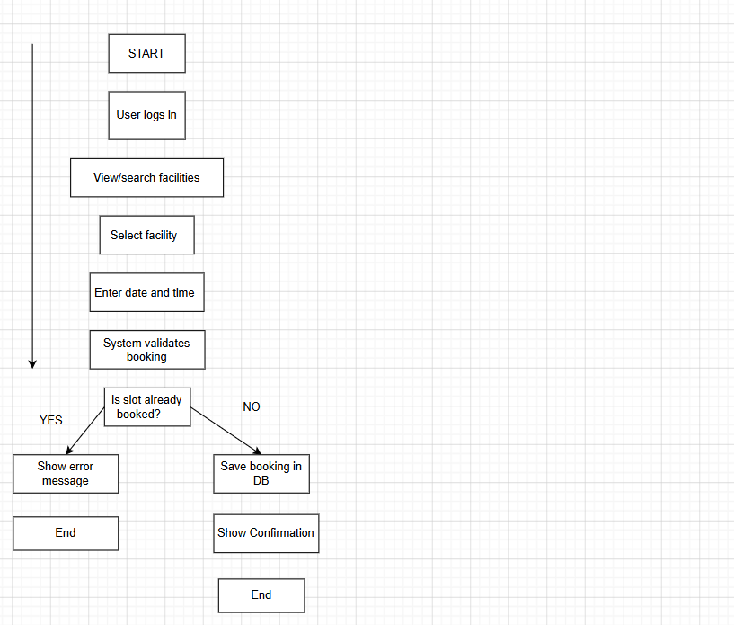

Summary
This section presented the design structure of the Sports Facility Booking Application. It explained the user interface design, database design, software architecture and major system workflows. These designs provided the foundation for the implementation stage discussed in the next chapter.

Chapter 5:Implementation and Testing or
Research Results and Result Analysis

Software Implementation or Research Results
This chapter explains how the Sports Facility Booking Application was implemented and how the final system was transformed from the software design presented in Chapter 4 into a fully functional web application.
The application was developed using Python Flask as the backend framework. Flask was responsible for managing application routes, user authentication, validation processes and interactions with the SQLite database. SQLite was selected as the database management system because it is lightweight and easy to integrate into small to medium-sized applications.
The frontend of the application was developed using HTML and CSS. HTML was used to structure webpages while CSS was used to improve the visual design of the system. A modern dark-blue themed user interface was implemented to improve user experience and create a more professional appearance.
The final system successfully implemented multiple core functionalities.
User authentication Implementation:
A secure authentication system was implemented to allow users to register and log into the platform.
Features implemented include:
- user registration
- secure login
- logout functionality
- password hashing
- session timeout management
- role-based access control
The system allows both members and administrators to access different functionalities based on their assigned roles.

Homepage:
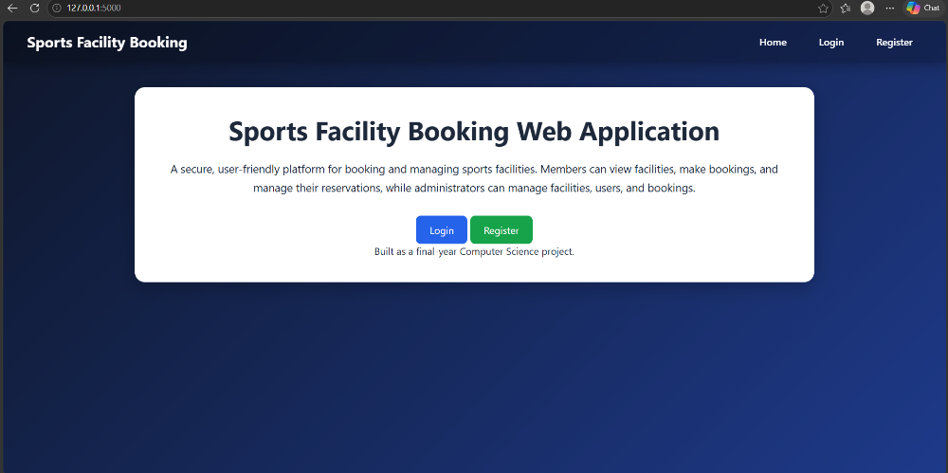
Registration Page:
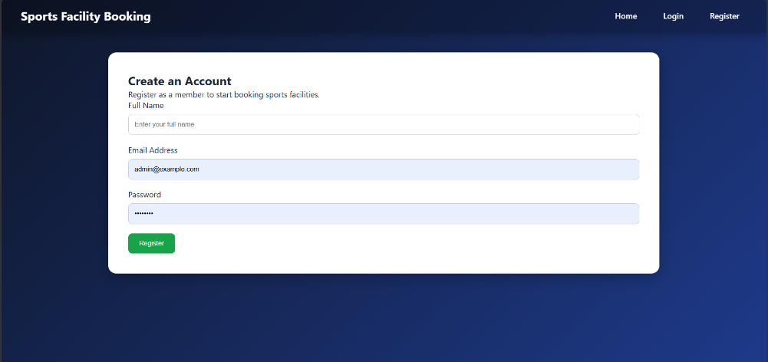
Login Page:
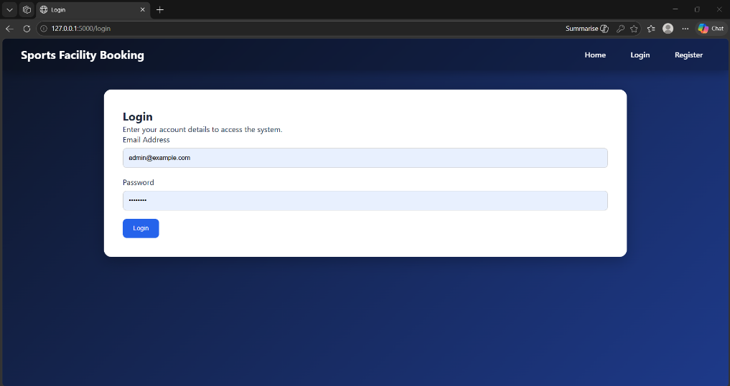

User Dashboard:
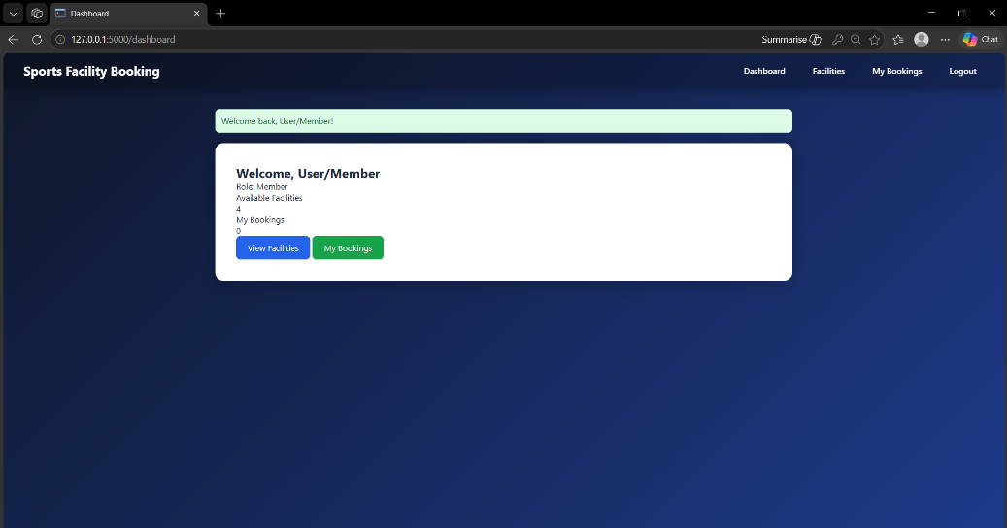
Admin Dashboard:
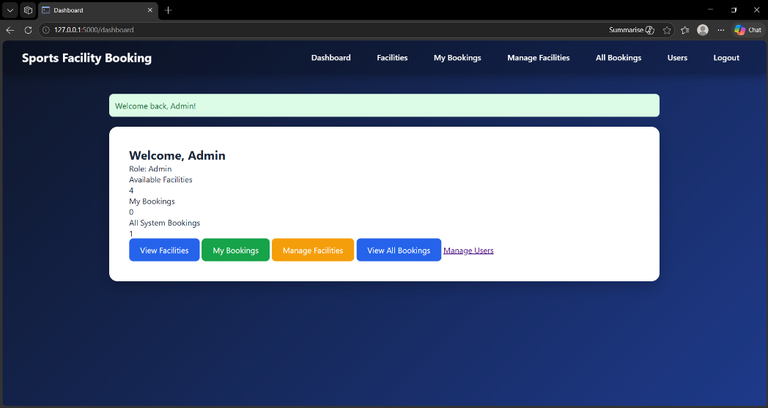

Facility Management Implementation
Users can browse and search available sports facilities through the system.
Features include:
- facility search functionality
- facility image display
- facility information display
Administrators can:
- add facilities
- edit facilities
- delete facilities

Facilities Page:
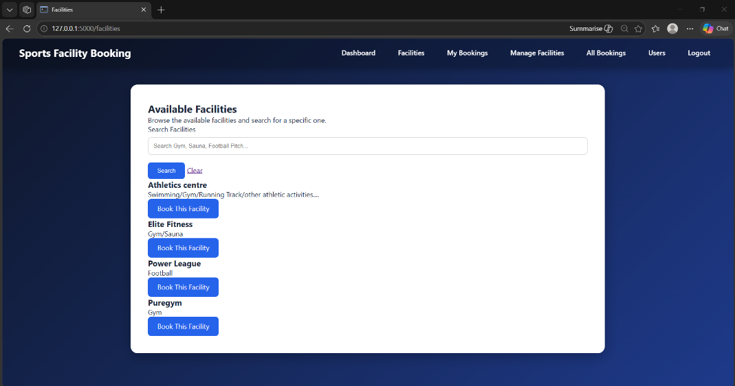
Manage Facilities page:
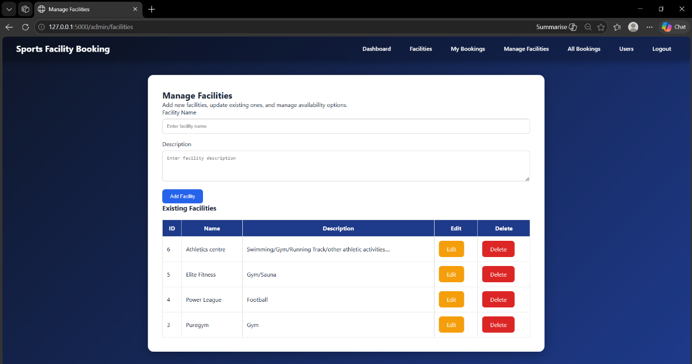
Booking management implementation:
The booking module represents the core functionality of the application.
Users can:
- select facilities
- choose booking dates
- choose booking times
- confirm bookings
- cancel bookings
Validation mechanisms were implemented to ensure booking accuracy.
These include:
- prevention of duplicate bookings
- prevention of booking past dates
- restriction of booking hours
The system also automatically displays booking statuses such as upcoming and completed bookings.
Booking Page:
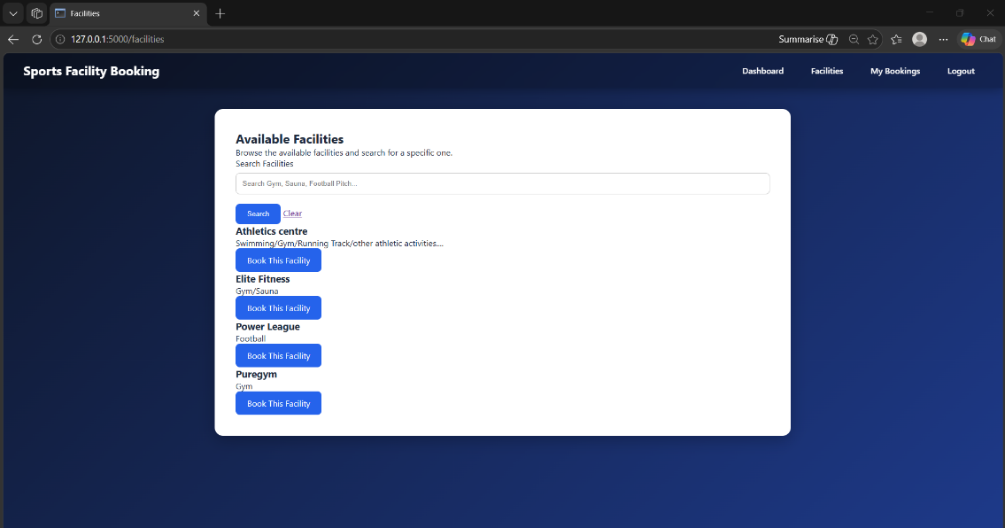

Booking Confirmation Page:
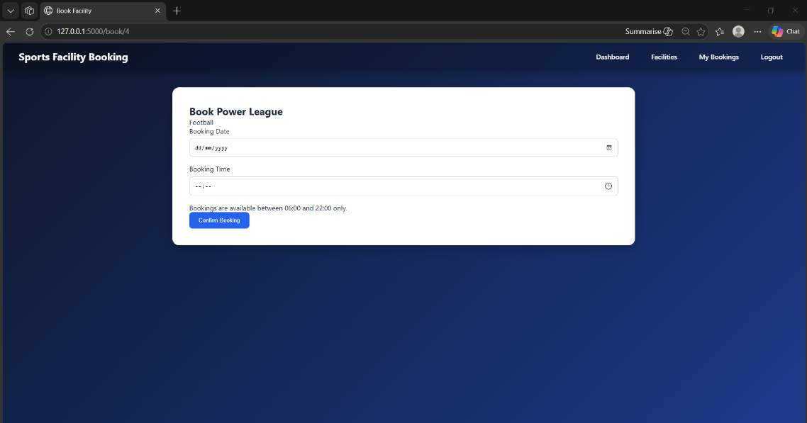
My Bookings Page:
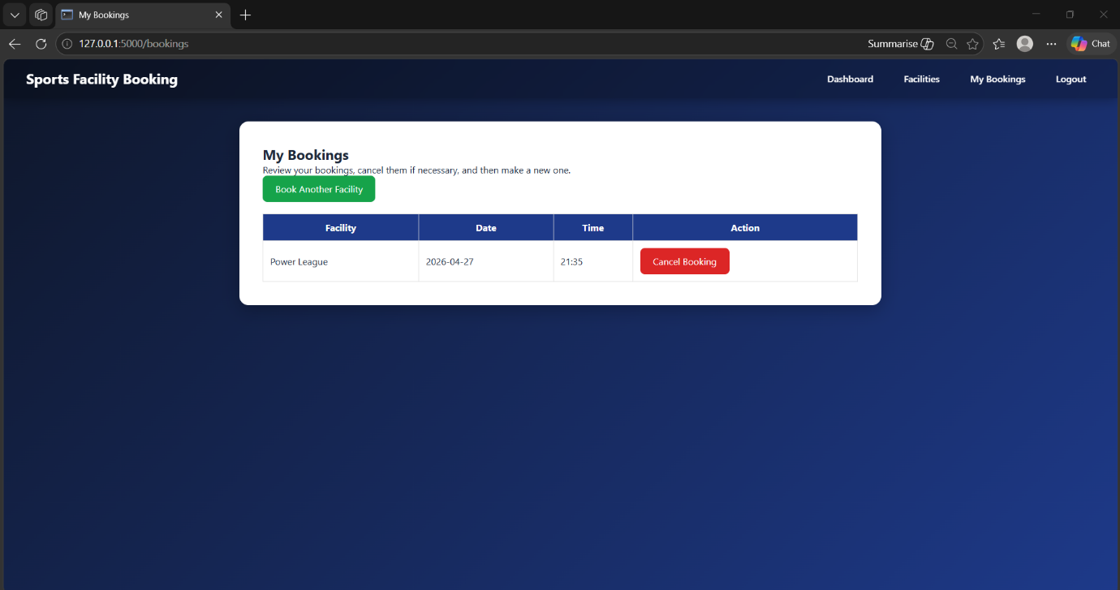

Administrative Features Implementation
Administrators were provided with advanced control features to manage system operations.
These features include:
- viewing all bookings
- deleting bookings
- managing users
- deleting users
- exporting booking reports as CSV files
- viewing system analytics
These features significantly improve operational control
Admin Bookings Page:
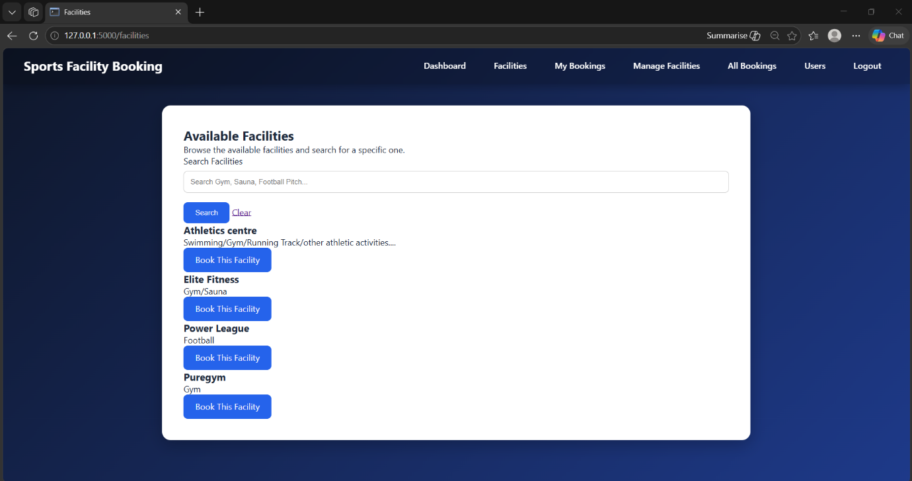

Admin Users Page:
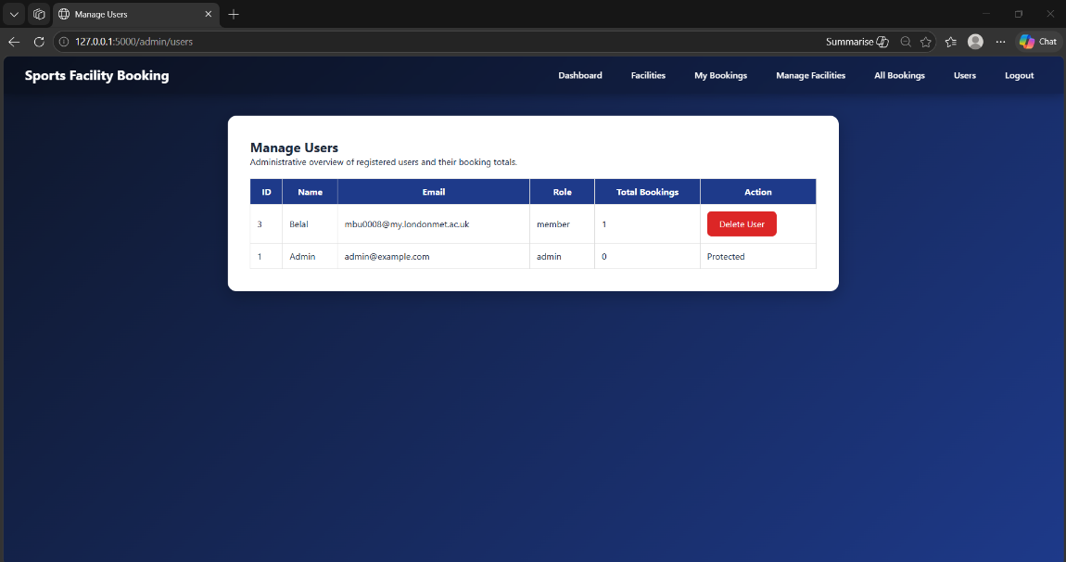
Export Booking Page:
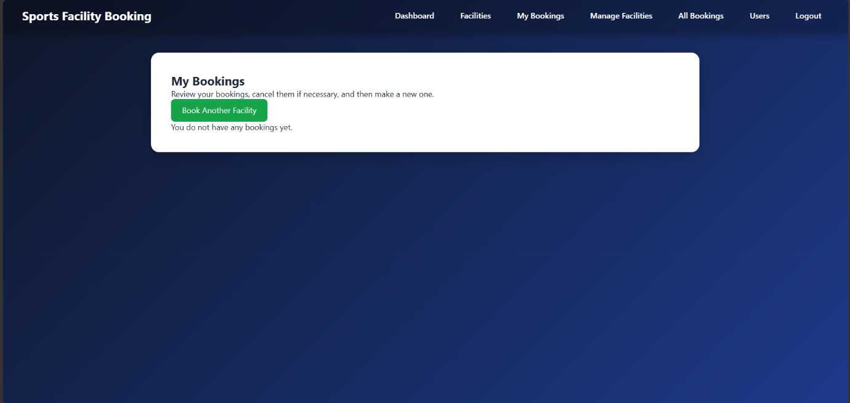
The final implementation exceeded the original project scope by introducing additional features such as booking analytics, CSV exporting, facility search functionality and improved interface design.

System Development Challenges and Debugging Process
During the development of the Sports Facility Booking Application, several technical challenges were encountered that required debugging, redesign and iterative problem solving.
One of the earliest issues occurred during database management. During development, the SQLite database was accidentally deleted which caused all existing records, including user accounts and facility data, to be lost. This required the database structure to be recreated. The database schema was rebuilt using SQLite commands and the application was reconfigured to automatically recreate essential tables when required. Administrative login credentials also needed to be restored.
Another major challenge involved route configuration within Flask. At one stage of development, incorrect route naming caused application errors when users attempted to access certain pages. For example, a route conflict occurred between the bookings page and my_bookings functionality, resulting in system errors. These issues were resolved by reviewing route names and ensuring proper consistency between Flask routes and HTML templates.
Template rendering issues also created significant challenges. During the booking process, users were sometimes redirected to blank white pages after attempting to confirm bookings. This issue was caused by missing HTML template integrations and incorrect rendering logic. The problem was solved by correcting template file structures and ensuring Flask properly rendered the required pages.
Administrative functionality also required multiple iterations. Initial versions of the administrator dashboard lacked full management capabilities. Additional features such as facility editing, booking deletion, user management and CSV exporting were later implemented to improve system functionality.
User interface design presented another challenge. Early versions of the platform were functional but lacked professional visual quality. The interface was redesigned multiple times to create a more modern appearance using improved CSS styling, navigation systems and facility image integration.
Testing also revealed booking validation issues. Additional logic was implemented to prevent duplicate bookings, restrict past date bookings and enforce valid booking time ranges.
These challenges demonstrated the importance of iterative development, debugging and continuous testing throughout software engineering projects. Overcoming these issues significantly improved both technical skills and problem-solving abilities.

Software Testing or Analysis of the results
Testing was conducted throughout the development process to ensure that the Sports Facility Booking Application functioned correctly and met the system requirements identified earlier.
The purpose of testing was to verify:
- that the system operates correctly
- that implemented features meet functional requirements
- that validation mechanisms function correctly
- that administrative controls operate effectively
A combination of functional testing and validation testing was carried out.
Functional Testing:
Functional testing was used to verify that system features performed as expected
Test Case | Expected Result | Actual Result | Status
User registration | User account created | Successful | Pass
User login | User logs into dashboard | Successful | Pass
Facility search | Correct facilities displayed | Successful | Pass
Book facility | Booking saved successfully | Successful | Pass
Cancel booking | Booking removed | Successful | Pass
Admin add facility | Facility added | Successful | Pass
Admin delete facility | Facility removed | Successful | Pass
Admin manage users | User deleted successfully | Successful | Pass
Export CSV report | File downloads | Successful | Pass

Validation Testing:
Validation testing ensured incorrect actions were prevented.
Validation Test | Expected Result | Actual Result | Status
Duplicate booking | Booking rejected | Successful | Pass
Past date booking | Booking rejected | Successful | Pass
Invalid login credentials | Login denied | Successful | Pass
Empty registration fields | Registration blocked | Successful | Pass

Testing Evidence:
Testing sessions were supported using system screenshots that demonstrate successful feature execution.
These screenshots show:
- successful bookings
- cancelled bookings
- admin management functions
- exported reports
- validation error messages
The results demonstrate that the final system successfully meets the original requirement specification defined in Chapter 3.
Additionally, the project exceeded initial requirements by implementing advanced features beyond the original scope.
This chapter demonstrated how the Sports Facility Booking Application was successfully implemented and tested. The testing results confirm that the system functions correctly and meets both user and administrative requirements.

Additional Testing Approaches
In addition to functional and validation testing, several other testing approaches were considered during the development of the Sports Facility Booking Application to improve system reliability.
Integration testing was carried out to ensure that different components of the system worked correctly together. For example, the booking system required successful interaction between the user interface, Flask application routes and SQLite database operations. When a user submitted a booking request, the system needed to validate the input, check booking availability and then successfully store the booking information in the database. These integrated processes were tested repeatedly to ensure smooth system performance.
Usability testing was also conducted to evaluate how easily users could navigate the system. Different users tested the application by registering accounts, searching facilities and completing bookings. Feedback from these tests helped improve navigation design, button placement and page layout. Earlier versions of the application were less visually appealing, which led to additional user interface improvements.
Boundary testing was also important during booking validation. Tests were performed to ensure that users could not book facilities outside permitted booking hours. The system successfully rejected booking attempts made before 06:00 and after 22:00.
Error handling testing was also performed. This involved deliberately entering invalid login credentials, duplicate booking requests and incomplete registration forms. These tests confirmed that the application displayed appropriate error messages and prevented invalid system behaviour.
Continuous testing throughout development helped identify bugs early and significantly improved overall system reliability.

Chapter 6:Evaluation of Results
This section critically evaluates the final Sports Facility Booking Application by assessing whether the project successfully achieved its original aims and objectives. It examines the strengths of the final system, identifies limitations and discusses areas where further improvements could be made.
The evaluation also compares the final implementation against the original requirements identified in Chapter 3.
The primary aim of this project was to develop a web-based sports facility booking application that improves booking efficiency and reduces the limitations of manual booking systems.
The final system successfully achieved its core objectives.
The system successfully implemented:
- user registration
- secure login system
- role-based access control
- facility browsing
- facility search functionality
- booking creation
- booking cancellation
- profile management
- facility management
- booking management
- user management
- CSV report exporting
- booking analytics dashboard
The system also successfully prevented duplicate bookings and invalid booking dates, which improved reliability.
The final implementation exceeded the original project proposal by introducing additional features such as analytics dashboards, improved user interface design and enhanced validation functionality.
Overall, the majority of project objectives were fully achieved.
One of the major strengths of the system is its simplicity and usability. Users can easily navigate the platform and complete bookings without requiring technical expertise.
Another strength is the implementation of role-based access control, which separates user functionality from administrative functionality.
The system also provides strong administrative control through features such as:
- facility management
- booking management
- user management
- CSV exporting

- Security was also improved through password hashing and session management.
- The modern interface design also improved professionalism and user experience.
- Despite the successful implementation of the project, several limitations remain.
- The system currently operates locally and is not deployed on a live cloud server.
- Online payment integration was not implemented.
- Email notifications and automated reminders were not included.
- The system currently uses SQLite, which may not be suitable for very large-scale organisations with high user traffic.
- The platform also lacks a dedicated mobile application.
- These limitations create opportunities for future improvements.
- Several challenges were encountered during development.
- Database issues occurred when the SQLite database was accidentally deleted during development, requiring reconstruction of the database.
- Template rendering issues caused blank pages during the booking workflow and required debugging.
- Route naming conflicts also caused navigation errors.
- User interface redesign required additional time to improve visual quality.
These challenges improved problem-solving abilities and contributed to learning throughout the project.
This chapter critically evaluated the final Sports Facility Booking Application. The results show that the project successfully met its primary objectives while identifying several areas for future improvement.

System Performance and Scalability Evaluation
The current implementation performs effectively for small to medium-sized sports organisations. During testing, the application handled user registrations, bookings, administrative tasks and database interactions without noticeable delays.
SQLite was selected because it provides lightweight database management and performs well for smaller applications. However, its scalability is limited compared to enterprise-level database systems such as MySQL or PostgreSQL. If the application were deployed for large universities or national sports organisations, a more scalable database system would likely be required.
The Flask framework also performs efficiently for smaller applications due to its lightweight design. However, large-scale deployment would require additional infrastructure such as cloud hosting, load balancing and stronger database architecture.
The current system also stores facility images through external URLs. While this simplified implementation, future systems may require dedicated file storage solutions.
From a usability perspective, the application performs well due to its simple navigation structure and responsive design. Users can complete booking actions quickly with minimal training.
Administrative scalability was also improved through analytics dashboards and CSV export functionality. These features allow administrators to manage growing amounts of booking data more efficiently.

Future scalability improvements could include:
- migration to cloud hosting platforms
- integration with larger databases
- mobile application deployment
- real-time booking synchronisation
- automated notifications
- payment systems
- API integrations

Commercial Viability and Real-World Application
The final Sports Facility Booking Application demonstrates strong potential for real-world implementation within small to medium-sized sports organisations. Many local gyms, community leisure centres, educational institutions and private sports facilities continue to rely on outdated booking methods such as spreadsheets, telephone bookings and manual scheduling systems. These approaches often create unnecessary administrative workload and increase the risk of booking conflicts.
The developed application provides an affordable alternative to expensive commercial platforms such as Mindbody and TeamUp. Many commercial booking platforms charge monthly subscription fees which may be financially challenging for smaller organisations. In contrast, this project demonstrates how a custom-built booking platform can deliver core functionality without high operating costs.
The application could be particularly useful for university sports departments where students frequently reserve sports halls, gym spaces and football pitches. The platform could also be adapted for martial arts gyms, swimming centres or independent sports academies.
From a business perspective, future integration of payment systems could transform the platform into a commercial product. Organisations could charge customers directly through the application, generating additional revenue while simplifying administrative processes.
Cloud deployment would also improve accessibility by allowing users to access the system from any location. Integration with mobile applications would further improve customer convenience.
Although the current project remains an academic prototype, its practical functionality demonstrates clear potential for future commercial development and wider implementation within the sports industry.

Comparison Between Final System and Initial Proposal
At the beginning of the project, the initial proposal focused primarily on creating a basic sports booking platform that would allow users to register, log in and reserve facilities online. The original project scope was relatively limited and focused mainly on replacing manual booking methods with a digital alternative.
During development, the final system evolved significantly beyond the original proposal. Additional features were introduced as development progressed and system requirements became clearer.
For example, the original proposal did not include facility search functionality. This feature was later introduced to improve usability by allowing users to quickly locate specific facilities.
The original proposal also did not include booking cancellation functionality. This became an important feature because users needed flexibility when managing their reservations.
Administrative features were also significantly expanded. Initially, administrators were only expected to manage facilities. However, the final system also allows administrators to manage users, delete bookings, export CSV reports and monitor booking analytics.
The user interface also improved substantially compared to the original design. Earlier versions of the system were functional but visually basic. Later redesign efforts introduced a modern interface with improved navigation and facility images.
These improvements demonstrate how iterative development allowed the project to evolve beyond its original scope.
However, some original ambitions were intentionally excluded. For example, payment integration and cloud deployment were not implemented due to time limitations and technical complexity.
Overall, the final system exceeded the original proposal and delivered a more comprehensive solution than initially planned.

Chapter 7:Conclusions
This project successfully designed, developed and implemented a fully functional Sports Facility Booking Application that improves the efficiency of sports facility reservations through digital automation.
The project addressed common problems associated with manual booking systems such as scheduling conflicts, inefficient record management and limited accessibility. By developing a web-based solution, users are now able to register accounts, search facilities, make bookings, cancel bookings and manage their profiles more efficiently.
Administrators are also provided with powerful management tools including facility management, booking management, user management, analytics monitoring and CSV report exporting.
The final implementation successfully applied software engineering principles including requirements analysis, system design, database design, implementation, testing and evaluation.
The project exceeded its original scope by implementing additional features such as:
- facility search functionality
- facility image integration
- booking analytics dashboard
- CSV exporting
- improved user interface design
Overall, the project demonstrates the successful development of a practical and scalable booking solution.
This project provided valuable practical experience in software development and project management.
Throughout development, important technical skills were improved including:
- Flask web development
- database design
- SQL operations
- debugging
- frontend design
- software testing
The project also improved problem-solving skills due to various technical challenges encountered during development.
Time management and iterative development were also important lessons learned throughout the project lifecycle.
The project provided practical experience in transforming theoretical software engineering knowledge into a real-world application.
Although the final system is fully functional, several future improvements could further enhance the application.
Potential future developments include:
- cloud deployment for public access
- online payment integration
- email notifications and reminders
- mobile application development
- real-time availability updates
- advanced analytics reporting
- integration with university membership systems
These improvements would increase scalability and make the system more suitable for larger organisations.
This project was both technically challenging and highly rewarding. It provided practical experience in full-stack development and demonstrated the importance of planning, testing and continuous improvement.
The final product reflects significant growth in technical ability and problem-solving skills. The project successfully achieved its objectives and produced a system that could be further developed into a real commercial solution.

Appendices

Appendix A: Project Management

1.1 The original project plan from the Proposal
The original project plan was created at the beginning of the project to ensure that sufficient time was allocated to research, system design, development, testing and report writing. The plan followed a structured timeline across the academic year to ensure the project could be completed before the final submission deadline.
No. | Activity | Estimated Duration | Activity Description
1 | Project topic selection | 1 week | Identify suitable project topic and confirm project idea with supervisor
2 | Proposal development | 2 weeks | Prepare project proposal document including objectives, scope and methodology
3 | Literature search | 2 weeks | Search for academic books, journals and online resources related to booking systems
4 | Literature review | 3 weeks | Critically review existing systems, technologies and research papers
5 | Requirements analysis | 2 weeks | Identify functional and non-functional requirements
6 | System design | 3 weeks | Design database structure, architecture diagrams and user interfaces
7 | Database development | 2 weeks | Create database tables and relationships using SQLite
8 | Backend development | 4 weeks | Develop Flask routes, authentication and booking logic
9 | Frontend development | 3 weeks | Build HTML templates and CSS styling
10 | System integration | 2 weeks | Connect frontend, backend and database components
11 | Testing and debugging | 3 weeks | Conduct testing, fix bugs and improve functionality
12 | Evaluation and improvements | 2 weeks | Review final system and implement improvements
13 | Final report writing | 3 weeks | Complete report chapters and formatting
14 | Final proofreading and submission | 1 week | Final checks and submission preparation
The original project plan provided a structured roadmap for completing the project within the academic year. The plan ensured that each development phase received appropriate attention while allowing flexibility for unexpected technical issues. Although minor delays occurred during implementation due to debugging challenges, the overall project remained close to the original schedule.

1.2 Review of your project process
The project initially progressed according to schedule during the research and design phases. However, during implementation several technical challenges caused minor delays.
These included:
- database reconstruction after accidental deletion
- debugging routing errors
- fixing blank template pages
- improving user interface design
Despite these challenges, the project was completed successfully and remained close to the planned schedule.
Overall, the project remained largely on target.

1.3 Amendments to the original plan

Several changes were made to the original project plan during development.

Additional features were added beyond the initial proposal including:

facility search functionality

booking cancellation

analytics dashboard

CSV exporting

improved user profile management

improved UI design

These additions required minor adjustments to the original schedule.

When minor delays occurred during development, additional development sessions were scheduled to recover lost time.
Tasks were prioritised by focusing on core functionality before implementing advanced features.
This ensured that the final system was completed within the required submission deadline.

1.4 Lessons learned in project management
This project highlighted the importance of time management, planning and risk management.
Unexpected technical issues demonstrated the need for backup planning and regular progress reviews.
Breaking the project into smaller milestones helped maintain progress throughout development.
Future projects would benefit from earlier testing and stronger backup procedures.

References
Dawson, C. (2015) Projects in Computing and Information Systems: A Student’s Guide. 3rd edn. Pearson Education.
Flask (2026) Flask Documentation. Available at: https://flask.palletsprojects.com/ (Accessed: 5 May 2026).
Laudon, K.C. and Laudon, J.P. (2020) Management Information Systems: Managing the Digital Firm. 16th edn. Pearson.
Mindbody (2026) Fitness and Wellness Booking Platform. Available at: https://www.mindbodyonline.com/ (Accessed: 5 May 2026).
Pressman, R.S. and Maxim, B.R. (2020) Software Engineering: A Practitioner’s Approach. 9th edn. McGraw-Hill.
SQLite (2026) SQLite Documentation. Available at: https://www.sqlite.org/docs.html (Accessed: 5 May 2026).
Sommerville, I. (2016) Software Engineering. 10th edn. Pearson.
TeamUp (2026) Gym Management Software. Available at: https://goteamup.com/ (Accessed: 5 May 2026).
Werkzeug (2026) Werkzeug Documentation. Available at: https://werkzeug.palletsprojects.com/ (Accessed: 5 May 2026).

